Assignment 2

1. Task-1: Develop a website using HTML and CSS of screens designed in assignment-1 task-2.

**Answers:-**

Screen:-1 Shopping Cart

<!DOCTYPE html>

<html lang="en">

<head>

<meta charset="UTF-8">

<meta name="viewport" content="width=device-width, initial-scale=1.0">

<title>Shopping cart</title>

<style>

.shoppingcart-container {

width: 100%;

display: flex;

overflow: auto;

min-height: 100vh;

align-items: center;

flex-direction: column;

}

.shoppingcart-shoppingcart {

width: 100%;

height: 1024px;

display: flex;

overflow: hidden;

position: relative;

align-items: flex-start;

flex-shrink: 0;

background-color: rgba(255, 255, 255, 1);

}

.shoppingcart-tomato {

top: 301px;

left: 96px;

width: 821px;

height: 159px;

display: flex;

overflow: hidden;

position: absolute;

align-items: flex-start;

flex-shrink: 0;

border-color: rgba(230, 230, 230, 1);

border-style: solid;

border-width: 2px;

border-radius: 24px;

background-color: rgba(250, 250, 245, 1);

}

.shoppingcart-text {

top: 24px;

left: 184px;

color: rgba(0, 0, 0, 1);

height: auto;

position: absolute;

font-size: 20px;

font-style: Semi Bold;

text-align: left;

font-family: Inter;

font-weight: 700;

line-height: 129.99999523162842%;

font-stretch: normal;

text-decoration: none;

}

.shoppingcart-text02 {

top: 24px;

left: 740px;

color: rgba(0, 0, 0, 1);

height: auto;

position: absolute;

font-size: 20px;

font-style: Semi Bold;

text-align: right;

font-family: Inter;

font-weight: 700;

line-height: 129.99999523162842%;

font-stretch: normal;

text-decoration: none;

}

.shoppingcart-text04 {

top: 54px;

left: 184px;

color: rgba(66, 107, 31, 1);

height: auto;

position: absolute;

font-size: 20px;

font-style: Semi Bold;

text-align: left;

font-family: Inter;

font-weight: 700;

line-height: 129.99999523162842%;

font-stretch: normal;

text-decoration: none;

}

.shoppingcart-inputfield {

gap: 10px;

top: 95px;

left: 184px;

width: 128px;

height: 40px;

display: flex;

padding: 8px 16px;

overflow: hidden;

position: absolute;

align-items: center;

flex-shrink: 0;

border-color: rgba(0, 0, 0, 0.05999999865889549);

border-style: solid;

border-width: 2px;

border-radius: 20px;

justify-content: center;

background-color: rgba(255, 255, 255, 1);

}

.shoppingcart-text06 {

top: 9.5px;

left: 16px;

color: rgba(0, 0, 0, 1);

height: auto;

position: absolute;

font-size: 16px;

font-style: Semi Bold;

text-align: left;

font-family: Inter;

font-weight: 700;

line-height: 129.99999523162842%;

font-stretch: normal;

text-decoration: none;

}

.shoppingcart-icon {

top: 4px;

left: 88px;

width: 32px;

height: 32px;

display: flex;

position: absolute;

align-items: flex-start;

flex-shrink: 0;

}

.shoppingcart-union {

top: 7.855770587921143px;

left: 8.398505210876465px;

width: 16px;

height: 16px;

position: absolute;

}

.shoppingcart-edoneil-avvd-zlh-dow-aunsplash1 {

top: 0px;

left: 0px;

width: 160px;

height: 160px;

position: absolute;

}

.shoppingcart-ginger {

top: 491px;

left: 96px;

width: 821px;

height: 159px;

display: flex;

overflow: hidden;

position: absolute;

align-items: flex-start;

flex-shrink: 0;

border-color: rgba(230, 230, 230, 1);

border-style: solid;

border-width: 2px;

border-radius: 24px;

background-color: rgba(250, 250, 245, 1);

}

.shoppingcart-text08 {

top: 24px;

left: 184px;

color: rgba(0, 0, 0, 1);

height: auto;

position: absolute;

font-size: 20px;

font-style: Semi Bold;

text-align: left;

font-family: Inter;

font-weight: 700;

line-height: 129.99999523162842%;

font-stretch: normal;

text-decoration: none;

}

.shoppingcart-text10 {

top: 54px;

left: 184px;

color: rgba(66, 107, 31, 1);

height: auto;

position: absolute;

font-size: 20px;

font-style: Semi Bold;

text-align: left;

font-family: Inter;

font-weight: 700;

line-height: 129.99999523162842%;

font-stretch: normal;

text-decoration: none;

}

.shoppingcart-inputfield1 {

gap: 10px;

top: 95px;

left: 184px;

width: 128px;

height: 40px;

display: flex;

padding: 8px 16px;

overflow: hidden;

position: absolute;

align-items: center;

flex-shrink: 0;

border-color: rgba(0, 0, 0, 0.05999999865889549);

border-style: solid;

border-width: 2px;

border-radius: 20px;

justify-content: center;

background-color: rgba(255, 255, 255, 1);

}

.shoppingcart-text12 {

top: 9.5px;

left: 16px;

color: rgba(0, 0, 0, 1);

height: auto;

position: absolute;

font-size: 16px;

font-style: Bold;

text-align: left;

font-family: Inter;

font-weight: 700;

line-height: 129.99999523162842%;

font-stretch: normal;

text-decoration: none;

}

.shoppingcart-icon1 {

top: 4px;

left: 88px;

width: 32px;

height: 32px;

display: flex;

position: absolute;

align-items: flex-start;

flex-shrink: 0;

}

.shoppingcart-union1 {

top: 7.855770587921143px;

left: 8.398505210876465px;

width: 16px;

height: 16px;

position: absolute;

}

.shoppingcart-text14 {

top: 24px;

left: 740px;

color: rgba(0, 0, 0, 1);

height: auto;

position: absolute;

font-size: 20px;

font-style: Semi Bold;

text-align: right;

font-family: Inter;

font-weight: 700;

line-height: 129.99999523162842%;

font-stretch: normal;

text-decoration: none;

}

.shoppingcart-noonbrewzi-cb4e-kmakunsplash {

top: 0px;

left: 0px;

width: 160px;

height: 160px;

position: absolute;

}

.shoppingcart-onion {

top: 681px;

left: 96px;

width: 821px;

height: 159px;

display: flex;

overflow: hidden;

position: absolute;

align-items: flex-start;

flex-shrink: 0;

border-color: rgba(230, 230, 230, 1);

border-style: solid;

border-width: 2px;

border-radius: 24px;

background-color: rgba(250, 250, 245, 1);

}

.shoppingcart-text16 {

top: 24px;

left: 184px;

color: rgba(0, 0, 0, 1);

height: auto;

position: absolute;

font-size: 20px;

font-style: Semi Bold;

text-align: left;

font-family: Inter;

font-weight: 700;

line-height: 129.99999523162842%;

font-stretch: normal;

text-decoration: none;

}

.shoppingcart-text18 {

top: 54px;

left: 184px;

color: rgba(66, 107, 31, 1);

height: auto;

position: absolute;

font-size: 20px;

font-style: Semi Bold;

text-align: left;

font-family: Inter;

font-weight: 700;

line-height: 129.99999523162842%;

font-stretch: normal;

text-decoration: none;

}

.shoppingcart-inputfield2 {

gap: 10px;

top: 95px;

left: 184px;

width: 128px;

height: 40px;

display: flex;

padding: 8px 16px;

overflow: hidden;

position: absolute;

align-items: center;

flex-shrink: 0;

border-color: rgba(0, 0, 0, 0.05999999865889549);

border-style: solid;

border-width: 2px;

border-radius: 20px;

justify-content: center;

background-color: rgba(255, 255, 255, 1);

}

.shoppingcart-text20 {

top: 9.5px;

left: 16px;

color: rgba(0, 0, 0, 1);

height: auto;

position: absolute;

font-size: 16px;

font-style: Bold;

text-align: left;

font-family: Inter;

font-weight: 700;

line-height: 129.99999523162842%;

font-stretch: normal;

text-decoration: none;

}

.shoppingcart-icon2 {

top: 4px;

left: 88px;

width: 32px;

height: 32px;

display: flex;

position: absolute;

align-items: flex-start;

flex-shrink: 0;

}

.shoppingcart-union2 {

top: 7.855770587921143px;

left: 8.398505210876465px;

width: 16px;

height: 16px;

position: absolute;

}

.shoppingcart-text22 {

top: 24px;

left: 730px;

color: rgba(0, 0, 0, 1);

height: auto;

position: absolute;

font-size: 20px;

font-style: Semi Bold;

text-align: right;

font-family: Inter;

font-weight: 700;

line-height: 129.99999523162842%;

font-stretch: normal;

text-decoration: none;

}

.shoppingcart-k80fk-p-hulv-munsplash2 {

top: 0px;

left: 0px;

width: 160px;

height: 160px;

position: absolute;

}

.shoppingcart-summary {

top: 301px;

left: 949px;

width: 395px;

height: 318px;

display: flex;

overflow: hidden;

position: absolute;

align-items: flex-start;

flex-shrink: 0;

border-color: rgba(230, 230, 230, 1);

border-style: solid;

border-width: 2px;

border-radius: 24px;

background-color: rgba(250, 250, 245, 1);

}

.shoppingcart-text24 {

top: 24px;

left: 24px;

color: rgba(0, 0, 0, 1);

height: auto;

position: absolute;

font-size: 20px;

font-style: Semi Bold;

text-align: left;

font-family: Inter;

font-weight: 700;

line-height: 129.99999523162842%;

font-stretch: normal;

text-decoration: none;

}

.shoppingcart-text26 {

top: 82px;

left: 24px;

color: rgba(0, 0, 0, 1);

height: auto;

position: absolute;

font-size: 16px;

font-style: Regular;

text-align: left;

font-family: Inter;

font-weight: 400;

line-height: 129.99999523162842%;

font-stretch: normal;

text-decoration: none;

}

.shoppingcart-text28 {

top: 82px;

left: 319px;

color: rgba(0, 0, 0, 1);

height: auto;

position: absolute;

font-size: 16px;

font-style: Regular;

text-align: right;

font-family: Inter;

font-weight: 400;

line-height: 129.99999523162842%;

font-stretch: normal;

text-decoration: none;

}

.shoppingcart-text30 {

top: 119px;

left: 24px;

color: rgba(0, 0, 0, 1);

height: auto;

position: absolute;

font-size: 16px;

font-style: Regular;

text-align: left;

font-family: Inter;

font-weight: 400;

line-height: 129.99999523162842%;

font-stretch: normal;

text-decoration: none;

}

.shoppingcart-text32 {

top: 119px;

left: 326px;

color: rgba(0, 0, 0, 1);

height: auto;

position: absolute;

font-size: 16px;

font-style: Regular;

text-align: right;

font-family: Inter;

font-weight: 400;

line-height: 129.99999523162842%;

font-stretch: normal;

text-decoration: none;

}

.shoppingcart-text34 {

top: 156px;

left: 24px;

color: rgba(0, 0, 0, 1);

height: auto;

position: absolute;

font-size: 16px;

font-style: Regular;

text-align: left;

font-family: Inter;

font-weight: 400;

line-height: 129.99999523162842%;

font-stretch: normal;

text-decoration: none;

}

.shoppingcart-text36 {

top: 156px;

left: 327px;

color: rgba(0, 0, 0, 1);

height: auto;

position: absolute;

font-size: 16px;

font-style: Regular;

text-align: right;

font-family: Inter;

font-weight: 400;

line-height: 129.99999523162842%;

font-stretch: normal;

text-decoration: none;

}

.shoppingcart-text38 {

top: 193px;

left: 24px;

color: rgba(0, 0, 0, 1);

height: auto;

position: absolute;

font-size: 16px;

font-style: Semi Bold;

text-align: left;

font-family: Inter;

font-weight: 700;

line-height: 129.99999523162842%;

font-stretch: normal;

text-decoration: none;

}

.shoppingcart-text40 {

top: 190px;

left: 314px;

color: rgba(0, 0, 0, 1);

height: auto;

position: absolute;

font-size: 16px;

font-style: Semi Bold;

text-align: right;

font-family: Inter;

font-weight: 700;

line-height: 129.99999523162842%;

font-stretch: normal;

text-decoration: none;

}

.shoppingcart-button {

gap: 8px;

top: 246px;

left: 24px;

width: 347px;

height: 48px;

display: flex;

padding: 10px 8px 10px 16px;

overflow: hidden;

position: absolute;

align-items: center;

flex-shrink: 0;

border-radius: 8px;

background-color: rgba(66, 107, 31, 1);

}

.shoppingcart-text42 {

top: 14px;

left: 24px;

color: rgba(255, 255, 255, 1);

height: auto;

position: absolute;

font-size: 16px;

font-style: Semi Bold;

text-align: left;

font-family: Inter;

font-weight: 700;

line-height: 129.99999523162842%;

font-stretch: normal;

text-decoration: none;

}

.shoppingcart-icon3 {

top: 8px;

left: 299px;

width: 32px;

height: 32px;

position: absolute;

}

.shoppingcart-pageheading {

top: 112px;

left: 0px;

width: 1440px;

height: 149px;

display: flex;

overflow: hidden;

position: absolute;

align-items: flex-start;

flex-shrink: 0;

background-color: rgba(255, 255, 255, 1);

}

.shoppingcart-text44 {

top: 90px;

left: 301px;

color: rgba(0, 0, 0, 1);

height: auto;

position: absolute;

font-size: 20px;

font-style: Light;

text-align: left;

font-family: Inter;

font-weight: 300;

line-height: 129.99999523162842%;

font-stretch: normal;

text-decoration: none;

}

.shoppingcart-text46 {

top: 56px;

left: 96px;

color: rgba(0, 0, 0, 1);

height: auto;

position: absolute;

font-size: 64px;

font-style: Regular;

text-align: left;

font-family: Newsreader;

font-weight: 400;

line-height: 120.00000476837158%;

font-stretch: normal;

text-decoration: none;

}

.shoppingcart-divider {

top: 149px;

left: 96px;

width: 1248px;

height: 1px;

position: absolute;

box-shadow: 0px 4px 4px 0px rgba(0, 0, 0, 0.25) ;

}

.shoppingcart-navigation {

top: 0px;

left: 0px;

width: 1440px;

height: 112px;

display: flex;

overflow: hidden;

position: absolute;

align-items: flex-start;

flex-shrink: 0;

}

.shoppingcart-text48 {

top: 41px;

left: 96px;

color: rgba(66, 107, 31, 1);

height: auto;

position: absolute;

font-size: 32px;

font-style: Medium;

text-align: left;

font-family: Newsreader;

font-weight: 500;

line-height: 100%;

font-stretch: normal;

text-decoration: none;

}

.shoppingcart-text50 {

top: 45.5px;

left: 744px;

color: rgba(0, 0, 0, 1);

height: auto;

position: absolute;

font-size: 16px;

font-style: Regular;

text-align: center;

font-family: Inter;

font-weight: 400;

line-height: 129.99999523162842%;

font-stretch: normal;

text-decoration: none;

}

.shoppingcart-text52 {

top: 45.5px;

left: 831px;

color: rgba(0, 0, 0, 1);

height: auto;

position: absolute;

font-size: 16px;

font-style: Regular;

text-align: center;

font-family: Inter;

font-weight: 400;

line-height: 129.99999523162842%;

font-stretch: normal;

text-decoration: none;

}

.shoppingcart-text54 {

top: 45.5px;

left: 956px;

color: rgba(0, 0, 0, 1);

height: auto;

position: absolute;

font-size: 16px;

font-style: Regular;

text-align: center;

font-family: Inter;

font-weight: 400;

line-height: 129.99999523162842%;

font-stretch: normal;

text-decoration: none;

}

.shoppingcart-text56 {

top: 45.5px;

left: 1094px;

color: rgba(0, 0, 0, 1);

height: auto;

position: absolute;

font-size: 16px;

font-style: Regular;

text-align: center;

font-family: Inter;

font-weight: 400;

line-height: 129.99999523162842%;

font-stretch: normal;

text-decoration: none;

}

.shoppingcart-cartbutton {

gap: 8px;

top: 32px;

left: 1218px;

width: 126px;

height: 48px;

display: flex;

padding: 14px 23px;

overflow: hidden;

position: absolute;

align-items: center;

flex-shrink: 0;

border-radius: 4px;

justify-content: center;

background-color: rgba(66, 107, 31, 1);

}

.shoppingcart-text58 {

top: 13.5px;

left: 23px;

color: rgba(255, 255, 255, 1);

height: auto;

position: absolute;

font-size: 16px;

font-style: Semi Bold;

text-align: center;

font-family: Inter;

font-weight: 700;

line-height: 129.99999523162842%;

font-stretch: normal;

text-decoration: none;

}

</style>

</head>

<body>

<div>

<div class="shoppingcart-container">

<div class="shoppingcart-shoppingcart">

<div class="shoppingcart-tomato">

<span class="shoppingcart-text"><span>Heirloom tomato</span></span>

<span class="shoppingcart-text02"><span>$5.99</span></span>

<span class="shoppingcart-text04"><span>$5.99 / lb</span></span>

<div class="shoppingcart-inputfield">

<span class="shoppingcart-text06"><span>1 lb</span></span>

<div class="shoppingcart-icon">

<img

src="/union4368-gawk.svg"

alt="Union4368"

class="shoppingcart-union"

/>

</div>

</div>

<img

src="/edoneilavvdzlhdowaunsplash14521-wx5-200h.png"

alt="edoneilAvvdZlhDowAunsplash14521"

class="shoppingcart-edoneil-avvd-zlh-dow-aunsplash1"

/>

</div>

<div class="shoppingcart-ginger">

<span class="shoppingcart-text08"><span>Organic ginger</span></span>

<span class="shoppingcart-text10"><span>$12.99 / lb</span></span>

<div class="shoppingcart-inputfield1">

<span class="shoppingcart-text12"><span>0.5 lb</span></span>

<div class="shoppingcart-icon1">

<img

src="/union4368-8gb.svg"

alt="Union4368"

class="shoppingcart-union1"

/>

</div>

</div>

<span class="shoppingcart-text14"><span>$6.50</span></span>

<img

src="/noonbrewzicb4ekmakunsplash4521-0f2m-200h.png"

alt="noonbrewziCb4EKmakunsplash4521"

class="shoppingcart-noonbrewzi-cb4e-kmakunsplash"

/>

</div>

<div class="shoppingcart-onion">

<span class="shoppingcart-text16"><span>Sweet onion</span></span>

<span class="shoppingcart-text18"><span>$2.99 / lb</span></span>

<div class="shoppingcart-inputfield2">

<span class="shoppingcart-text20"><span>5 lb</span></span>

<div class="shoppingcart-icon2">

<img

src="/union4368-45hf.svg"

alt="Union4368"

class="shoppingcart-union2"

/>

</div>

</div>

<span class="shoppingcart-text22"><span>$14.95</span></span>

<img

src="/k80fkphulvmunsplash24521-f55b-200h.png"

alt="k80fkPHulvMunsplash24521"

class="shoppingcart-k80fk-p-hulv-munsplash2"

/>

</div>

<div class="shoppingcart-summary">

<span class="shoppingcart-text24"><span>Order summary</span></span>

<span class="shoppingcart-text26"><span>Subtotal</span></span>

<span class="shoppingcart-text28"><span>$27.44</span></span>

<span class="shoppingcart-text30"><span>Shipping</span></span>

<span class="shoppingcart-text32"><span>$3.99</span></span>

<span class="shoppingcart-text34"><span>Tax</span></span>

<span class="shoppingcart-text36"><span>$2.00</span></span>

<span class="shoppingcart-text38"><span>Total</span></span>

<span class="shoppingcart-text40"><span>$33.43</span></span>

<button class="shoppingcart-button">

<span class="shoppingcart-text42">

<span>Continue to payment</span>

</span>

<img

src="/icon4368-sger.svg"

alt="Icon4368"

class="shoppingcart-icon3"

/>

</button>

</div>

<div class="shoppingcart-pageheading">

<span class="shoppingcart-text44"><span>3 items</span></span>

<span class="shoppingcart-text46"><span>Basket</span></span>

<img

src="/divider4368-gyyci.svg"

alt="Divider4368"

class="shoppingcart-divider"

/>

</div>

<div class="shoppingcart-navigation">

<span class="shoppingcart-text48"><span>World Peas</span></span>

<span class="shoppingcart-text50"><span>Shop</span></span>

<span class="shoppingcart-text52"><span>Newstand</span></span>

<span class="shoppingcart-text54"><span>Who we are</span></span>

<span class="shoppingcart-text56"><span>My profile</span></span>

<button class="shoppingcart-cartbutton">

<span class="shoppingcart-text58"><span>Basket (3)</span></span>

</button>

</div>

</div>

</div>

</div>

</body>

</html> Output:-

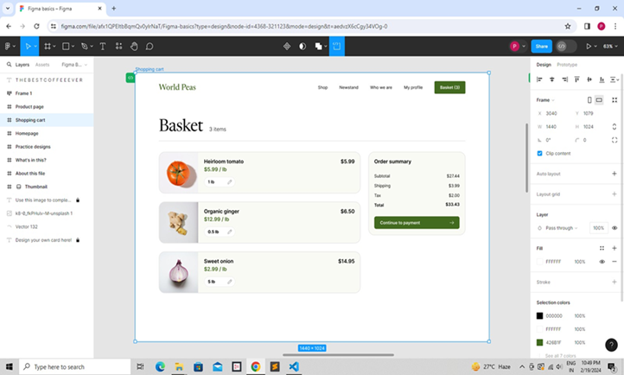

Screen:-2 Product Page

<!DOCTYPE html>

<html lang="en">

<head>

<meta charset="UTF-8">

<meta name="viewport" content="width=device-width, initial-scale=1.0">

<title>Product page</title>

<style>

.productpage-container {

width: 100%;

display: flex;

overflow: auto;

min-height: 100vh;

align-items: center;

flex-direction: column;

}

.productpage-productpage {

width: 100%;

height: 1024px;

display: flex;

overflow: hidden;

position: relative;

align-items: flex-start;

flex-shrink: 0;

background-color: rgba(255, 255, 255, 1);

}

.productpage-pageheading {

top: 112px;

left: 0px;

width: 1440px;

height: 149px;

display: flex;

overflow: hidden;

position: absolute;

align-items: flex-start;

flex-shrink: 0;

background-color: rgba(255, 255, 255, 1);

}

.productpage-defaultchip {

gap: 8px;

top: 76px;

left: 1077px;

width: 88px;

height: 40px;

display: flex;

padding: 10px 16px;

overflow: hidden;

position: absolute;

align-items: center;

flex-shrink: 0;

border-radius: 20px;

justify-content: center;

background-color: rgba(66, 107, 31, 1);

}

.productpage-text {

top: 9.5px;

left: 16px;

color: rgba(255, 255, 255, 1);

height: auto;

position: absolute;

font-size: 16px;

font-style: Semi Bold;

text-align: center;

font-family: Inter;

font-weight: 700;

line-height: 129.99999523162842%;

font-stretch: normal;

text-decoration: none;

}

.productpage-a-zchip {

gap: 8px;

top: 76px;

left: 1173px;

width: 62px;

height: 40px;

display: flex;

padding: 10px 16px;

overflow: hidden;

position: absolute;

align-items: center;

flex-shrink: 0;

border-color: rgba(194, 194, 194, 1);

border-style: solid;

border-width: 1px;

border-radius: 20px;

justify-content: center;

background-color: rgba(255, 255, 255, 1);

}

.productpage-text02 {

top: 9.5px;

left: 16px;

color: rgba(0, 0, 0, 1);

height: auto;

position: absolute;

font-size: 16px;

font-style: Semi Bold;

text-align: center;

font-family: Inter;

font-weight: 700;

line-height: 129.99999523162842%;

font-stretch: normal;

text-decoration: none;

}

.productpage-listchip {

gap: 8px;

top: 76px;

left: 1243px;

width: 101px;

height: 40px;

display: flex;

padding: 10px 16px;

overflow: hidden;

position: absolute;

align-items: center;

flex-shrink: 0;

border-color: rgba(194, 194, 194, 1);

border-style: solid;

border-width: 1px;

border-radius: 20px;

justify-content: center;

background-color: rgba(255, 255, 255, 1);

}

.productpage-text04 {

top: 9.5px;

left: 16px;

color: rgba(0, 0, 0, 1);

height: auto;

position: absolute;

font-size: 16px;

font-style: Semi Bold;

text-align: center;

font-family: Inter;

font-weight: 700;

line-height: 129.99999523162842%;

font-stretch: normal;

text-decoration: none;

}

.productpage-text06 {

top: 90px;

left: 347px;

color: rgba(0, 0, 0, 1);

height: auto;

position: absolute;

font-size: 20px;

font-style: Medium;

text-align: left;

font-family: Inter;

font-weight: 500;

line-height: 129.99999523162842%;

font-stretch: normal;

text-decoration: none;

}

.productpage-text07 {

font-weight: 500;

}

.productpage-text09 {

top: 56px;

left: 96px;

color: rgba(0, 0, 0, 1);

height: auto;

position: absolute;

font-size: 64px;

font-style: Regular;

text-align: left;

font-family: Newsreader;

font-weight: 400;

line-height: 120.00000476837158%;

font-stretch: normal;

text-decoration: none;

}

.productpage-divider {

top: 149px;

left: 96px;

width: 1248px;

height: 1px;

position: absolute;

box-shadow: 0px 4px 4px 0px rgba(0, 0, 0, 0.25) ;

}

.productpage-navigation {

top: 0px;

left: 0px;

width: 1440px;

height: 112px;

display: flex;

overflow: hidden;

position: absolute;

align-items: flex-start;

flex-shrink: 0;

}

.productpage-text11 {

top: 41px;

left: 96px;

color: rgba(66, 107, 31, 1);

height: auto;

position: absolute;

font-size: 32px;

font-style: Medium;

text-align: left;

font-family: Newsreader;

font-weight: 500;

line-height: 100%;

font-stretch: normal;

text-decoration: none;

}

.productpage-text13 {

top: 45.5px;

left: 744px;

color: rgba(0, 0, 0, 1);

height: auto;

position: absolute;

font-size: 16px;

font-style: Regular;

text-align: center;

font-family: Inter;

font-weight: 400;

line-height: 129.99999523162842%;

font-stretch: normal;

text-decoration: none;

}

.productpage-text15 {

top: 45.5px;

left: 831px;

color: rgba(0, 0, 0, 1);

height: auto;

position: absolute;

font-size: 16px;

font-style: Regular;

text-align: center;

font-family: Inter;

font-weight: 400;

line-height: 129.99999523162842%;

font-stretch: normal;

text-decoration: none;

}

.productpage-text17 {

top: 45.5px;

left: 956px;

color: rgba(0, 0, 0, 1);

height: auto;

position: absolute;

font-size: 16px;

font-style: Regular;

text-align: center;

font-family: Inter;

font-weight: 400;

line-height: 129.99999523162842%;

font-stretch: normal;

text-decoration: none;

}

.productpage-text19 {

top: 45.5px;

left: 1094px;

color: rgba(0, 0, 0, 1);

height: auto;

position: absolute;

font-size: 16px;

font-style: Regular;

text-align: center;

font-family: Inter;

font-weight: 400;

line-height: 129.99999523162842%;

font-stretch: normal;

text-decoration: none;

}

.productpage-cartbutton {

gap: 8px;

top: 32px;

left: 1218px;

width: 126px;

height: 48px;

display: flex;

padding: 14px 23px;

overflow: hidden;

position: absolute;

align-items: center;

flex-shrink: 0;

border-radius: 8px;

justify-content: center;

background-color: rgba(66, 107, 31, 1);

}

.productpage-text21 {

top: 13.5px;

left: 23px;

color: rgba(255, 255, 255, 1);

height: auto;

position: absolute;

font-size: 16px;

font-style: Semi Bold;

text-align: center;

font-family: Inter;

font-weight: 700;

line-height: 129.99999523162842%;

font-stretch: normal;

text-decoration: none;

}

.productpage-tomato {

top: 301px;

left: 96px;

width: 395px;

height: 444px;

display: flex;

overflow: hidden;

position: absolute;

align-items: flex-start;

flex-shrink: 0;

border-color: rgba(230, 230, 230, 1);

border-style: solid;

border-width: 2px;

border-radius: 24px;

background-color: rgba(250, 250, 245, 1);

}

.productpage-text23 {

top: 320px;

left: 24px;

color: rgba(0, 0, 0, 1);

height: auto;

position: absolute;

font-size: 20px;

font-style: Semi Bold;

text-align: left;

font-family: Inter;

font-weight: 700;

line-height: 129.99999523162842%;

font-stretch: normal;

text-decoration: none;

}

.productpage-text25 {

top: 350px;

left: 24px;

color: rgba(66, 107, 31, 1);

height: auto;

position: absolute;

font-size: 20px;

font-style: Semi Bold;

text-align: left;

font-family: Inter;

font-weight: 700;

line-height: 129.99999523162842%;

font-stretch: normal;

text-decoration: none;

}

.productpage-text27 {

top: 392px;

left: 24px;

color: rgba(109, 109, 109, 1);

height: auto;

position: absolute;

font-size: 16px;

font-style: Regular;

text-align: left;

font-family: Inter;

font-weight: 400;

line-height: 150%;

font-stretch: normal;

text-decoration: none;

}

.productpage-edoneil-avvd-zlh-dow-aunsplash1 {

top: 0px;

left: 0px;

width: 395px;

height: 296px;

position: absolute;

}

.productpage-ginger {

top: 301px;

left: 523px;

width: 395px;

height: 444px;

display: flex;

overflow: hidden;

position: absolute;

align-items: flex-start;

flex-shrink: 0;

border-color: rgba(230, 230, 230, 1);

border-style: solid;

border-width: 2px;

border-radius: 24px;

background-color: rgba(250, 250, 245, 1);

}

.productpage-text29 {

top: 320px;

left: 24px;

color: rgba(0, 0, 0, 1);

height: auto;

position: absolute;

font-size: 20px;

font-style: Semi Bold;

text-align: left;

font-family: Inter;

font-weight: 700;

line-height: 129.99999523162842%;

font-stretch: normal;

text-decoration: none;

}

.productpage-text31 {

top: 350px;

left: 24px;

color: rgba(66, 107, 31, 1);

height: auto;

position: absolute;

font-size: 20px;

font-style: Semi Bold;

text-align: left;

font-family: Inter;

font-weight: 700;

line-height: 129.99999523162842%;

font-stretch: normal;

text-decoration: none;

}

.productpage-text33 {

top: 392px;

left: 24px;

color: rgba(109, 109, 109, 1);

height: auto;

position: absolute;

font-size: 16px;

font-style: Regular;

text-align: left;

font-family: Inter;

font-weight: 400;

line-height: 150%;

font-stretch: normal;

text-decoration: none;

}

.productpage-noonbrewzi-cb4e-kmakunsplash {

top: 0px;

left: 0px;

width: 395px;

height: 296px;

position: absolute;

}

</style>

</head>

<body>

<div>

<div class="productpage-container">

<div class="productpage-productpage">

<div class="productpage-pageheading">

<div class="productpage-defaultchip">

<span class="productpage-text"><span>Default</span></span>

</div>

<div class="productpage-a-zchip">

<span class="productpage-text02"><span>A-Z</span></span>

</div>

<div class="productpage-listchip">

<span class="productpage-text04"><span>List view</span></span>

</div>

<span class="productpage-text06">

<span class="productpage-text07">Fresh</span>

<span>— August 21, 2023</span>

</span>

<span class="productpage-text09"><span>Produce</span></span>

<img

src="/divider4368-o6a.svg"

alt="Divider4368"

class="productpage-divider"

/>

</div>

<div class="productpage-navigation">

<span class="productpage-text11"><span>World Peas</span></span>

<span class="productpage-text13"><span>Shop</span></span>

<span class="productpage-text15"><span>Newstand</span></span>

<span class="productpage-text17"><span>Who we are</span></span>

<span class="productpage-text19"><span>My profile</span></span>

<button class="productpage-cartbutton">

<span class="productpage-text21"><span>Basket (3)</span></span>

</button>

</div>

<div class="productpage-tomato">

<span class="productpage-text23"><span>Heirloom tomato</span></span>

<span class="productpage-text25"><span>$5.99 / lb</span></span>

<span class="productpage-text27">

<span>Grown in San Juan Capistrano, CA</span>

</span>

<img

src="https://aheioqhobo.cloudimg.io/v7/_playground-bucket-v2.teleporthq.io_/a4004044-c009-433c-83bb-f7e5eae54458/865a2b99-97a7-49d9-8491-cb41f761686f?org_if_sml=1181877&amp;force_format=original"

alt="edoneilAvvdZlhDowAunsplash14521"

class="productpage-edoneil-avvd-zlh-dow-aunsplash1"

/>

</div>

<div class="productpage-ginger">

<span class="productpage-text29"><span>Organic ginger</span></span>

<span class="productpage-text31"><span>$12.99 / lb</span></span>

<span class="productpage-text33">

<span>Grown in Huntington Beach, CA</span>

</span>

<img

src="https://aheioqhobo.cloudimg.io/v7/_playground-bucket-v2.teleporthq.io_/a4004044-c009-433c-83bb-f7e5eae54458/bab426bf-fe60-404a-bcea-9a6a0727820c?org_if_sml=1135281&amp;force_format=original"

alt="noonbrewziCb4EKmakunsplash4521"

class="productpage-noonbrewzi-cb4e-kmakunsplash"

/>

</div>

</div>

</div>

</div>

</body>

</html>

Output:-

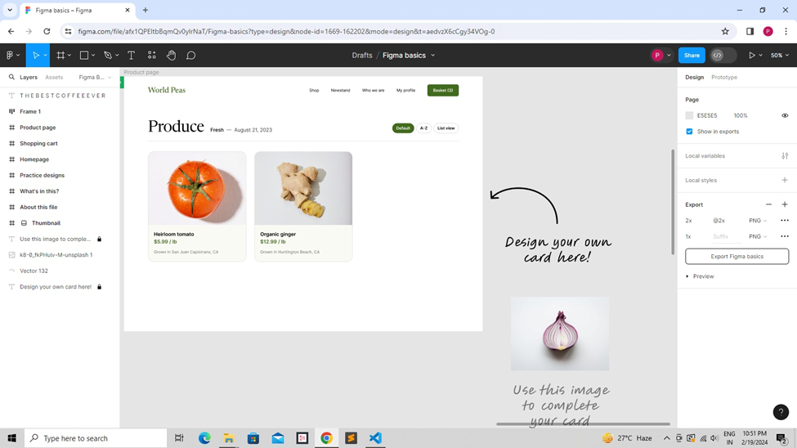

Screen:-3 Practice designs

<!DOCTYPE html>

<html lang="en">

<head>

<meta charset="UTF-8">

<meta name="viewport" content="width=device-width, initial-scale=1.0">

<title>Practice design</title>

<style>

.practicedesigns-container {

width: 100%;

display: flex;

overflow: auto;

min-height: 100vh;

align-items: center;

flex-direction: column;

}

.practicedesigns-practicedesigns {

width: 100%;

height: 720px;

display: flex;

overflow: hidden;

position: relative;

align-items: flex-start;

flex-shrink: 0;

background-color: rgba(15, 169, 88, 1);

}

.practicedesigns-shadow {

top: 326px;

left: 72px;

width: 797px;

height: 151px;

position: absolute;

}

.practicedesigns-bounding-headline {

gap: 10px;

top: 300.5px;

left: 48px;

width: 796px;

display: flex;

padding: 40px 32px 44px;

position: absolute;

box-sizing: content-box;

align-items: flex-start;

border-color: rgba(0, 0, 0, 1);

border-style: solid;

border-width: 4px;

background-color: rgba(255, 255, 255, 1);

}

.practicedesigns-corner {

top: 141px;

left: 787px;

width: 22px;

height: 22px;

position: absolute;

border-color: rgba(0, 0, 0, 1);

border-style: solid;

border-width: 4px;

}

.practicedesigns-corner1 {

top: 142px;

left: -13px;

width: 22px;

height: 22px;

z-index: 1;

position: absolute;

border-color: rgba(0, 0, 0, 1);

border-style: solid;

border-width: 4px;

}

.practicedesigns-corner2 {

top: -13px;

left: 787px;

width: 22px;

height: 22px;

z-index: 2;

position: absolute;

border-color: rgba(0, 0, 0, 1);

border-style: solid;

border-width: 4px;

}

.practicedesigns-corner3 {

top: -13px;

left: -13px;

width: 22px;

height: 22px;

z-index: 3;

position: absolute;

border-color: rgba(0, 0, 0, 1);

border-style: solid;

border-width: 4px;

}

.practicedesigns-text {

color: rgba(0, 0, 0, 1);

height: auto;

z-index: 4;

font-size: 96px;

font-style: Bold;

text-align: center;

font-family: Whyte Inktrap;

font-weight: 700;

line-height: 100%;

font-stretch: normal;

text-decoration: none;

}

.practicedesigns-vector {

top: -86px;

left: -281.9999084472656px;

width: 851.9998779296875px;

height: 844.2431640625px;

display: flex;

position: absolute;

align-items: flex-start;

flex-shrink: 1;

}

.practicedesigns-ellipse278 {

top: 0px;

left: 562.8287353515625px;

width: 398px;

height: 796px;

position: absolute;

}

.practicedesigns-ellipse277 {

top: 0px;

left: 562.8287353515625px;

width: 398px;

height: 796px;

position: absolute;

}

.practicedesigns-ellipse276 {

top: 273px;

left: 835.9998779296875px;

width: 16px;

height: 16px;

position: absolute;

border-color: rgba(0, 0, 0, 1);

border-style: solid;

border-width: 4px;

}

.practicedesigns-commonicon16pen {

top: 187px;

left: 576px;

width: 90px;

height: 90px;

display: flex;

position: absolute;

align-items: flex-start;

flex-shrink: 0;

}

.practicedesigns-union {

top: 0px;

left: 0px;

width: 86px;

height: 86px;

position: absolute;

}

.practicedesigns-union1 {

top: -0.015926361083984375px;

left: -0.015926361083984375px;

width: 86px;

height: 86px;

position: absolute;

}

.practicedesigns-cursor-labels {

top: 504px;

left: 940px;

width: 136px;

display: flex;

padding: 10px 25px 7.5px;

position: absolute;

align-items: flex-start;

border-color: rgba(0, 0, 0, 1);

border-style: solid;

border-width: 4px;

flex-direction: column;

background-color: rgba(255, 133, 119, 1);

}

.practicedesigns-cursor {

top: -46.25px;

left: -33.75px;

width: 46px;

height: 55px;

position: absolute;

}

</style>

</head>

<body>

<div>

<div class="practicedesigns-container">

<div class="practicedesigns-practicedesigns">

<img

src="https://aheioqhobo.cloudimg.io/v7/_playground-bucket-v2.teleporthq.io_/a4004044-c009-433c-83bb-f7e5eae54458/1230603a-4833-48fa-98c6-a05166de92c4?org_if_sml=1906&amp;force_format=original"

alt="Shadow4368"

class="practicedesigns-shadow"

/>

<div class="practicedesigns-bounding-headline">

<img

src="https://aheioqhobo.cloudimg.io/v7/_playground-bucket-v2.teleporthq.io_/a4004044-c009-433c-83bb-f7e5eae54458/da5e185a-5690-44a3-9ba9-0c4f4d5715c0?org_if_sml=1156&amp;force_format=original"

alt="corner4368"

class="practicedesigns-corner"

/>

<img

src="https://aheioqhobo.cloudimg.io/v7/_playground-bucket-v2.teleporthq.io_/a4004044-c009-433c-83bb-f7e5eae54458/af5947f6-050f-4ff0-9210-f8e9628de76e?org_if_sml=1156&amp;force_format=original"

alt="corner4368"

class="practicedesigns-corner1" />

<img

src="https://aheioqhobo.cloudimg.io/v7/_playground-bucket-v2.teleporthq.io_/a4004044-c009-433c-83bb-f7e5eae54458/2bc6d0b5-32c8-4254-a875-1eb3e8c28dcd?org_if_sml=1156&amp;force_format=original"

alt="corner4368"

class="practicedesigns-corner2" />

<img

src="https://aheioqhobo.cloudimg.io/v7/_playground-bucket-v2.teleporthq.io_/a4004044-c009-433c-83bb-f7e5eae54458/ee460338-6ba3-4aa3-9a13-9044959635ea?org_if_sml=1156&amp;force_format=original"

alt="corner4368"

class="practicedesigns-corn />

<span class="practicedesigns-text"><span>Practice designs</span></span>

</div>

<div class="practicedesigns-vector">

<img

src="/ellipse2784368-rl1i.svg"

alt="Ellipse2784368"

class="practicedesigns-ellipse278" />

<img

src="/ellipse2774368-hwsk.svg"

alt="Ellipse2774368"

class="practicedesigns-ellipse2 />

<img

src="https://aheioqhobo.cloudimg.io/v7/_playground-bucket-v2.teleporthq.io_/a4004044-c009-433c-83bb-f7e5eae54458/03e49bcd-fb65-4c46-9438-44729db5bea5?org_if_sml=1257&amp;force_format=original"

alt="Ellipse2764368"

class="practicedesigns-ellipse276" />

</div>

<div class="practicedesigns-commonicon16pen">

<img

src="/union4368-3586.svg"

alt="Union4368"

class="practicedesigns-union" />

<img

src="/union4368-73u.svg"

alt="Union4368"

class="practicedesigns-union1" />

</div>

<div class="practicedesigns-cursor-labels">

<img

src="/cursori4368-ds3.svg"

alt="CursorI4368"

class="practicedesigns-curso />

</div>

</div>

</div>

</div>

</body>

</html>

Output:-

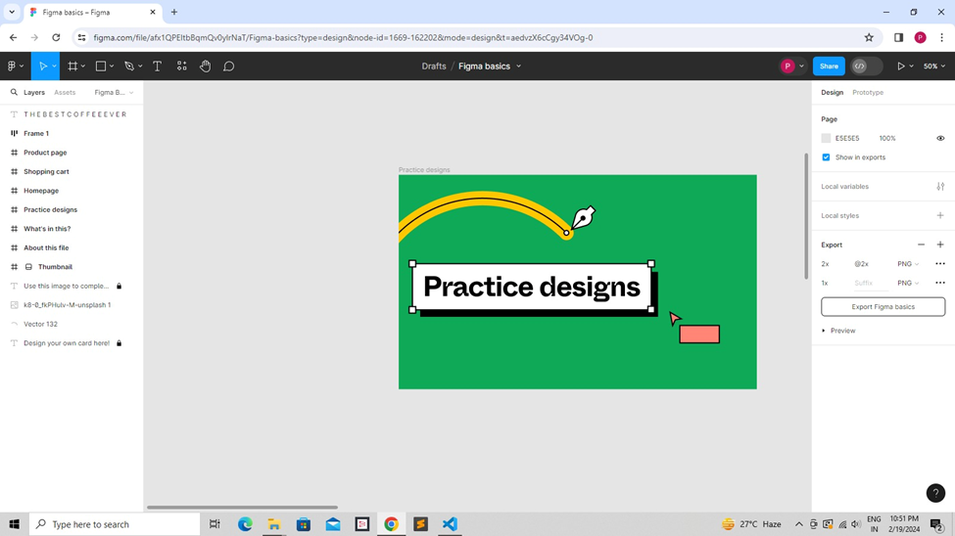

Screen:-4 Thumbnail

<!DOCTYPE html>

<html lang="en">

<head>

<meta charset="UTF-8">

<meta name="viewport" content="width=device-width, initial-scale=1.0">

<title>Thumbnail</title>

<style>

.thumbnail-container {

width: 100%;

display: flex;

overflow: auto;

min-height: 100vh;

align-items: center;

flex-direction: column;

}

.thumbnail-thumbnail {

width: 100%;

height: 720px;

display: flex;

overflow: hidden;

position: relative;

align-items: flex-start;

flex-shrink: 0;

background-color: rgba(255, 255, 255, 1);

}

.thumbnail-illo {

top: 747.16064453125px;

left: 752.5px;

width: 718.0006713867188px;

height: 180.16082763671875px;

display: flex;

position: absolute;

align-items: flex-start;

flex-shrink: 1;

}

.thumbnail-vector124 {

top: 0px;

left: 0px;

width: 718px;

height: 180px;

position: absolute;

}

.thumbnail-vector125 {

top: 0px;

left: 0px;

width: 718px;

height: 180px;

position: absolute;

}

.thumbnail-ellipse73 {

top: -115.66064453125px;

left: 111px;

width: 16px;

height: 16px;

position: absolute;

border-color: rgba(0, 0, 0, 1);

border-style: solid;

border-width: 4px;

}

.thumbnail-ellipse74 {

top: -98.16064453125px;

left: 251.25px;

width: 16px;

height: 16px;

position: absolute;

border-color: rgba(0, 0, 0, 1);

border-style: solid;

border-width: 4px;

}

.thumbnail-ellipse75 {

top: -124.41064453125px;

left: 350.25px;

width: 16px;

height: 16px;

position: absolute;

border-color: rgba(0, 0, 0, 1);

border-style: solid;

border-width: 4px;

}

.thumbnail-illo1 {

top: 60.25px;

left: -291.75px;

width: 713.5px;

height: 81.5px;

display: flex;

position: absolute;

align-items: flex-start;

flex-shrink: 1;

}

.thumbnail-vector126 {

top: 8px;

left: 0px;

width: 706px;

height: 72px;

position: absolute;

}

.thumbnail-vector127 {

top: 8px;

left: 0px;

width: 706px;

height: 72px;

position: absolute;

}

.thumbnail-ellipse66 {

top: 21.75px;

left: 697.5px;

width: 16px;

height: 16px;

position: absolute;

border-color: rgba(0, 0, 0, 1);

border-style: solid;

border-width: 4px;

}

.thumbnail-ellipse67 {

top: 61.5px;

left: 549px;

width: 16px;

height: 16px;

position: absolute;

border-color: rgba(0, 0, 0, 1);

border-style: solid;

border-width: 4px;

}

.thumbnail-ellipse68 {

top: 11px;

left: 508.5px;

width: 16px;

height: 16px;

position: absolute;

border-color: rgba(0, 0, 0, 1);

border-style: solid;

border-width: 4px;

}

.thumbnail-ellipse69 {

top: 65.25px;

left: 407.25px;

width: 16px;

height: 16px;

position: absolute;

border-color: rgba(0, 0, 0, 1);

border-style: solid;

border-width: 4px;

}

.thumbnail-ellipse70 {

top: 0px;

left: 401.25px;

width: 16px;

height: 16px;

position: absolute;

border-color: rgba(0, 0, 0, 1);

border-style: solid;

border-width: 4px;

}

.thumbnail-ellipse71 {

top: 68.75px;

left: 275.25px;

width: 13px;

height: 13px;

position: absolute;

border-color: rgba(0, 0, 0, 1);

border-style: solid;

border-width: 3.75px;

}

.thumbnail-ellipse72 {

top: 37.25px;

left: 275.25px;

width: 13px;

height: 13px;

position: absolute;

border-color: rgba(0, 0, 0, 1);

border-style: solid;

border-width: 3.75px;

}

.thumbnail-cursor-labels {

top: 568.25px;

left: 265.25px;

width: 136px;

display: flex;

padding: 10px 25px 7.5px;

position: absolute;

align-items: flex-start;

border-color: rgba(0, 0, 0, 1);

border-style: solid;

border-width: 4px;

flex-direction: column;

background-color: rgba(85, 81, 255, 1);

}

.thumbnail-cursor {

top: -46.25px;

left: 166.25px;

width: 46px;

height: 55px;

position: absolute;

}

.thumbnail-cursor-labels1 {

top: 50.75px;

left: 547px;

width: 136px;

display: flex;

padding: 10px 25px 7.5px;

position: absolute;

align-items: flex-start;

border-color: rgba(0, 0, 0, 1);

border-style: solid;

border-width: 4px;

flex-direction: column;

background-color: rgba(242, 78, 30, 1);

}

.thumbnail-cursor1 {

top: 107.25px;

left: -31.25px;

width: 46px;

height: 55px;

position: absolute;

}

.thumbnail-shadow {

top: 292px;

left: 72px;

width: 859px;

height: 184px;

position: absolute;

}

.thumbnail-bounding-headline {

gap: 10px;

top: 268px;

left: 48px;

width: 859px;

display: flex;

padding: 44px 32px 48px;

position: absolute;

box-sizing: content-box;

align-items: flex-start;

border-color: rgba(0, 0, 0, 1);

border-style: solid;

border-width: 4px;

background-color: rgba(255, 198, 0, 1);

}

.thumbnail-corner {

top: 174px;

left: 850px;

width: 22px;

height: 22px;

position: absolute;

border-color: rgba(0, 0, 0, 1);

border-style: solid;

border-width: 4px;

}

.thumbnail-corner1 {

top: 175px;

left: -13px;

width: 22px;

height: 22px;

z-index: 1;

position: absolute;

border-color: rgba(0, 0, 0, 1);

border-style: solid;

border-width: 4px;

}

.thumbnail-corner2 {

top: -13px;

left: 850px;

width: 22px;

height: 22px;

z-index: 2;

position: absolute;

border-color: rgba(0, 0, 0, 1);

border-style: solid;

border-width: 4px;

}

.thumbnail-corner3 {

top: -13px;

left: -13px;

width: 22px;

height: 22px;

z-index: 3;

position: absolute;

border-color: rgba(0, 0, 0, 1);

border-style: solid;

border-width: 4px;

}

.thumbnail-text {

color: rgba(0, 0, 0, 1);

height: auto;

z-index: 4;

font-size: 132px;

font-style: Bold;

text-align: center;

font-family: Whyte Inktrap;

font-weight: 700;

line-height: 100%;

font-stretch: normal;

text-decoration: none;

}

.thumbnail-cursor-labels2 {

top: 373.5px;

left: 1014.5px;

width: 136px;

display: flex;

padding: 10px 25px 7.5px;

position: absolute;

align-items: flex-start;

border-color: rgba(0, 0, 0, 1);

border-style: solid;

border-width: 4px;

flex-direction: column;

background-color: rgba(162, 89, 255, 1);

}

.thumbnail-cursor2 {

top: -46.25px;

left: -33.75px;

width: 46px;

height: 55px;

position: absolute;

}

</style>

</head>

<body>

<div>

<div class="thumbnail-container">

<div class="thumbnail-thumbnail">

<div class="thumbnail-illo">

<img

src="/vector1244368-4ccc.svg"

alt="Vector1244368"

class="thumbnail-vector124"

/>

<img

src="/vector1254368-xgz9.svg"

alt="Vector1254368"

class="thumbnail-vector125"

/>

<img

src="https://aheioqhobo.cloudimg.io/v7/_playground-bucket-v2.teleporthq.io_/a4004044-c009-433c-83bb-f7e5eae54458/07ef3cbe-9e43-4e06-aab2-a1c93f9ab11b?org_if_sml=1281&amp;force_format=original"

alt="Ellipse734368"

class="thumbnail-ellipse73"

/>

<img

src="https://aheioqhobo.cloudimg.io/v7/_playground-bucket-v2.teleporthq.io_/a4004044-c009-433c-83bb-f7e5eae54458/e94aa458-f2e8-4173-99e2-f40c13f77ea2?org_if_sml=1273&amp;force_format=original"

alt="Ellipse744368"

class="thumbnail-ellipse74"

/>

<img

src="https://aheioqhobo.cloudimg.io/v7/_playground-bucket-v2.teleporthq.io_/a4004044-c009-433c-83bb-f7e5eae54458/b2edb015-d0e1-4233-907d-91355f2a06c7?org_if_sml=1297&amp;force_format=original"

alt="Ellipse754368"

class="thumbnail-ellipse75"

/>

</div>

<div class="thumbnail-illo1">

<img

src="/vector1264368-osmn.svg"

alt="Vector1264368"

class="thumbnail-vector126"

/>

<img

src="/vector1274368-kiq.svg"

alt="Vector1274368"

class="thumbnail-vector127"

/>

<img

src="https://aheioqhobo.cloudimg.io/v7/_playground-bucket-v2.teleporthq.io_/a4004044-c009-433c-83bb-f7e5eae54458/97f72645-a3df-486f-8627-e87bbe795559?org_if_sml=1273&amp;force_format=original"

alt="Ellipse664368"

class="thumbnail-ellipse66"

/>

<img

src="https://aheioqhobo.cloudimg.io/v7/_playground-bucket-v2.teleporthq.io_/a4004044-c009-433c-83bb-f7e5eae54458/025b98b4-12da-47f3-90d9-4414b4ad0aaf?org_if_sml=1294&amp;force_format=original"

alt="Ellipse674368"

class="thumbnail-ellipse67"

/>

<img

src="https://aheioqhobo.cloudimg.io/v7/_playground-bucket-v2.teleporthq.io_/a4004044-c009-433c-83bb-f7e5eae54458/115562b8-df6a-456c-92ff-08882cbe0bf6?org_if_sml=1299&amp;force_format=original"

alt="Ellipse684368"

class="thumbnail-ellipse68"

/>

<img

src="https://aheioqhobo.cloudimg.io/v7/_playground-bucket-v2.teleporthq.io_/a4004044-c009-433c-83bb-f7e5eae54458/2c2c3452-d03b-4f5d-8b45-b568ed9bb10d?org_if_sml=1281&amp;force_format=original"

alt="Ellipse694368"

class="thumbnail-ellipse69"

/>

<img

src="https://aheioqhobo.cloudimg.io/v7/_playground-bucket-v2.teleporthq.io_/a4004044-c009-433c-83bb-f7e5eae54458/35ae190c-5a18-4d6b-8abb-470bc7f4d161?org_if_sml=1283&amp;force_format=original"

alt="Ellipse704368"

class="thumbnail-ellipse70"

/>

<img

src="https://aheioqhobo.cloudimg.io/v7/_playground-bucket-v2.teleporthq.io_/a4004044-c009-433c-83bb-f7e5eae54458/49ad132b-b52c-4d56-86b1-0dd7f23e8c51?org_if_sml=1123&amp;force_format=original"

alt="Ellipse714368"

class="thumbnail-ellipse71"

/>

<img

src="https://aheioqhobo.cloudimg.io/v7/_playground-bucket-v2.teleporthq.io_/a4004044-c009-433c-83bb-f7e5eae54458/0d1e34c5-1773-4ea7-ae9d-45cce4f1c097?org_if_sml=1123&amp;force_format=original"

alt="Ellipse724368"

class="thumbnail-ellipse72"

/>

</div>

<div class="thumbnail-cursor-labels">

<img

src="/cursor4368-f3de.svg"

alt="Cursor4368"

class="thumbnail-cursor"

/>

</div>

<div class="thumbnail-cursor-labels1">

<img

src="/cursor4368-jwon.svg"

alt="Cursor4368"

class="thumbnail-cursor1"

/>

</div>

<img

src="https://aheioqhobo.cloudimg.io/v7/_playground-bucket-v2.teleporthq.io_/a4004044-c009-433c-83bb-f7e5eae54458/940505c3-80d5-45aa-a3ed-534bcd47a8ef?org_if_sml=11123&amp;force_format=original"

alt="Shadow5080"

class="thumbnail-shadow"

/>

<div class="thumbnail-bounding-headline">

<img

src="https://aheioqhobo.cloudimg.io/v7/_playground-bucket-v2.teleporthq.io_/a4004044-c009-433c-83bb-f7e5eae54458/9dc5f774-afb8-4f11-8e2d-a73572aa6b53?org_if_sml=1144&amp;force_format=original"

alt="corner5082"

class="thumbnail-corner"

/>

<img

src="https://aheioqhobo.cloudimg.io/v7/_playground-bucket-v2.teleporthq.io_/a4004044-c009-433c-83bb-f7e5eae54458/a1d05a9b-8c2d-44dc-b3af-527ea05624ba?org_if_sml=1144&amp;force_format=original"

alt="corner5083"

class="thumbnail-corner1"

/>

<img

src="https://aheioqhobo.cloudimg.io/v7/_playground-bucket-v2.teleporthq.io_/a4004044-c009-433c-83bb-f7e5eae54458/597cc160-f0b7-4e1b-8040-db4a544e25ce?org_if_sml=1144&amp;force_format=original"

alt="corner5084"

class="thumbnail-corner2"

/>

<img

src="https://aheioqhobo.cloudimg.io/v7/_playground-bucket-v2.teleporthq.io_/a4004044-c009-433c-83bb-f7e5eae54458/0d21ae20-744a-46d0-badc-bcf8d579f07f?org_if_sml=1144&amp;force_format=original"

alt="corner5085"

class="thumbnail-corner3"

/>

<span class="thumbnail-text"><span>Figma basics</span></span>

</div>

<div class="thumbnail-cursor-labels2">

<img

src="/cursori4368-7lkq.svg"

alt="CursorI4368"

class="thumbnail-cursor2"

/>

</div>

</div>

</div>

</div>

</body>

</html>

Output:-

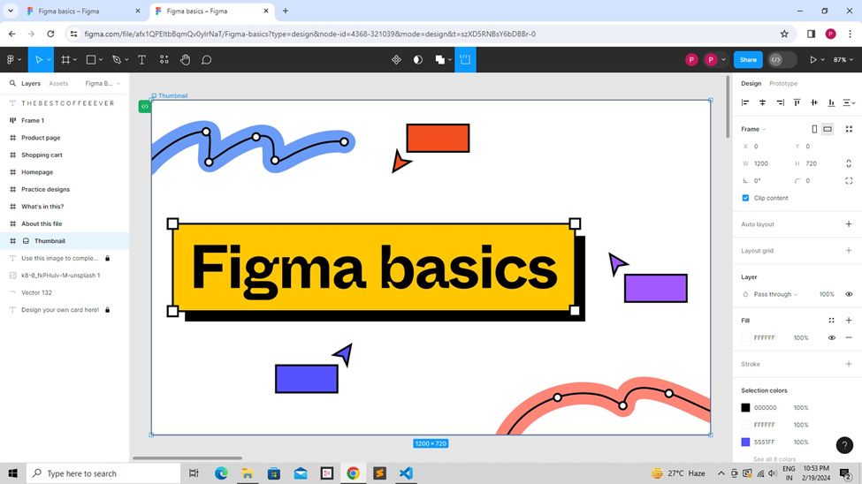

Screen:-5 Invitation Page

<!DOCTYPE html>

<html lang="en">

<head>

<meta charset="UTF-8">

<meta name="viewport" content="width=device-width, initial-scale=1.0">

<title>Invitation Page</title>

<style>

.invitation-page-container {

width: 100%;

display: flex;

overflow: auto;

min-height: 100vh;

align-items: center;

flex-direction: column;

}

.invitation-page-invitation-page {

width: 100%;

height: 4480px;

display: flex;

overflow: hidden;

position: relative;

align-items: flex-start;

flex-shrink: 0;

background-color: rgba(255, 255, 255, 1);

}

.invitation-page-frame2 {

top: 798px;

left: 1678px;

width: 100px;

height: 100px;

display: flex;

overflow: hidden;

position: absolute;

align-items: flex-start;

flex-shrink: 0;

background-color: rgba(255, 255, 255, 1);

}

.invitation-page-image16 {

top: 32px;

left: -24px;

width: 3504px;

height: 4480px;

position: absolute;

}

.invitation-page-text {

top: 2467px;

left: 864px;

color: rgba(0, 0, 0, 1);

height: auto;

position: absolute;

font-size: 128px;

font-style: Bold;

text-align: left;

font-family: Inter;

font-weight: 700;

line-height: normal;

font-stretch: normal;

text-decoration: none;

}

.invitation-page-text02 {

top: 607px;

left: 1188px;

color: rgba(0, 0, 0, 1);

height: auto;

position: absolute;

font-size: 128px;

font-style: Bold;

text-align: left;

font-family: Inter;

font-weight: 700;

line-height: normal;

font-stretch: normal;

text-decoration: none;

}

.invitation-page-text04 {

top: 1210px;

left: 764px;

color: rgba(0, 0, 0, 1);

height: auto;

position: absolute;

font-size: 128px;

font-style: Bold;

text-align: left;

font-family: Inter;

font-weight: 700;

line-height: normal;

font-stretch: normal;

text-decoration: none;

}

.invitation-page-text06 {

top: 1814px;

left: 924px;

color: rgba(0, 0, 0, 1);

height: auto;

position: absolute;

font-size: 128px;

font-style: Bold;

text-align: left;

font-family: Inter;

font-weight: 700;

line-height: normal;

font-stretch: normal;

text-decoration: none;

}

.invitation-page-text08 {

top: 2005px;

left: 741px;

color: rgba(0, 0, 0, 1);

height: auto;

position: absolute;

font-size: 128px;

font-style: Bold;

text-align: left;

font-family: Inter;

font-weight: 700;

line-height: normal;

font-stretch: normal;

text-decoration: none;

}

.invitation-page-text10 {

top: 2638px;

left: 628px;

color: rgba(0, 0, 0, 1);

height: auto;

position: absolute;

font-size: 128px;

font-style: Bold;

text-align: left;

font-family: Inter;

font-weight: 700;

line-height: normal;

font-stretch: normal;

text-decoration: none;

}

.invitation-page-text12 {

top: 2809px;

left: 950px;

color: rgba(0, 0, 0, 1);

height: auto;

position: absolute;

font-size: 128px;

font-style: Bold;

text-align: left;

font-family: Inter;

font-weight: 700;

line-height: normal;

font-stretch: normal;

text-decoration: none;

}

.invitation-page-text14 {

top: 3373px;

left: 848px;

color: rgba(0, 0, 0, 1);

height: auto;

position: absolute;

font-size: 128px;

font-style: Bold;

text-align: left;

font-family: Inter;

font-weight: 700;

line-height: normal;

font-stretch: normal;

text-decoration: none;

}

.invitation-page-text16 {

top: 3544px;

left: 1194px;

color: rgba(0, 0, 0, 1);

height: auto;

position: absolute;

font-size: 128px;

font-style: Bold;

text-align: left;

font-family: Inter;

font-weight: 700;

line-height: normal;

font-stretch: normal;

text-decoration: none;

}

.invitation-page-text18 {

top: 1456px;

left: 1228px;

color: rgba(0, 0, 0, 1);

height: auto;

position: absolute;

font-size: 128px;

font-style: Bold;

text-align: left;

font-family: Inter;

font-weight: 700;

line-height: normal;

font-stretch: normal;

text-decoration: none;

}

</style>

</head>

<body>

<div>

<div class="invitation-page-container">

<div class="invitation-page-invitation-page">

<div class="invitation-page-frame2"></div>

<img

src="https://aheioqhobo.cloudimg.io/v7/_playground-bucket-v2.teleporthq.io_/a4004044-c009-433c-83bb-f7e5eae54458/11b91c01-c665-4bb5-a9b5-ee9b8fa56d3e?org_if_sml=1213517&amp;force_format=original"

alt="image166797"

class="invitation-page-image16"/>

<span class="invitation-page-text">

<span>THE IVY COUNTRY CLUB</span>

</span>

<span class="invitation-page-text02"><span>Wel Come Dinner</span></span>

<span class="invitation-page-text04">

<span>PLEASE JOIN US IN HONOR OF</span>

</span>

<span class="invitation-page-text06">

<span>FRIDAY,JAN 20TH,2023</span>

</span>

<span class="invitation-page-text08">

<span>SIX O’CLOCK IN THE EVENING</span>

</span>

<span class="invitation-page-text10">

<span>5900 YERBA BUENA BOULEVARD</span>

</span>

<span class="invitation-page-text12"><span>AHMEDABAD-380050</span></span>

<span class="invitation-page-text14">

<span>KINDLY RSVP BY JULY 1ST</span>

</span>

<span class="invitation-page-text16"><span>999.000.0000</span></span>

<span class="invitation-page-text18"><span>KANANI FAMILY</span></span>

</div>

</div>

</div>

</body>

</html>

Output:-

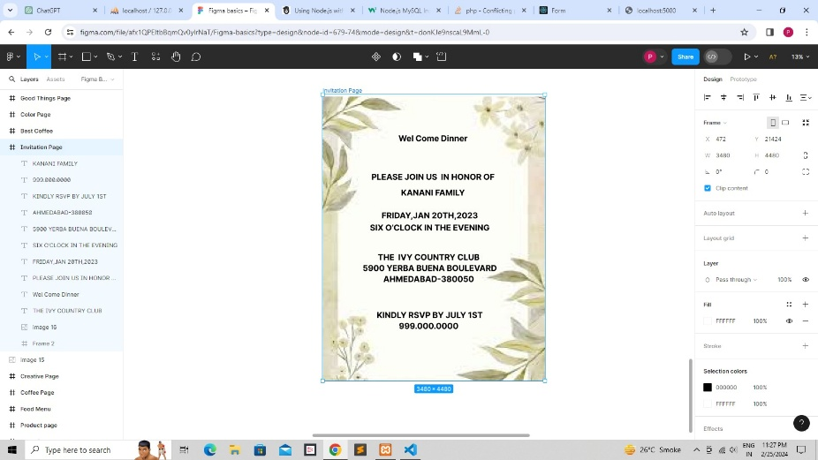

Screen:-6 What’s in this?

<!DOCTYPE html>

<html lang="en">

<head>

<meta charset="UTF-8">

<meta name="viewport" content="width=device-width, initial-scale=1.0">

<title>Whats in This</title>

<style>

.whatsinthis-container {

width: 100%;

display: flex;

overflow: auto;

min-height: 100vh;

align-items: center;

flex-direction: column;

}

.whatsinthis-whatsinthis {

width: 100%;

height: 720px;

display: flex;

overflow: hidden;

position: relative;

align-items: flex-start;

flex-shrink: 0;

background-color: rgba(255, 255, 255, 1);

}

.whatsinthis-text {

top: 96px;

left: 96px;

color: rgba(0, 0, 0, 1);

width: 716px;

height: auto;

position: absolute;

font-size: 48px;

font-style: Regular;

text-align: left;

font-family: Whyte;

font-weight: 400;

line-height: 150%;

font-stretch: normal;

text-decoration: none;

}

.whatsinthis-image1 {

top: 510px;

left: 102px;

width: 264px;

height: 210px;

position: absolute;

border-radius: 4px;

}

.whatsinthis-image2 {

top: 510px;

left: 450px;

width: 300px;

height: 213px;

position: absolute;

border-radius: 4px;

}

.whatsinthis-image3 {

top: 510px;

left: 798px;

width: 300px;

height: 228px;

position: absolute;

border-radius: 4px;

}

.whatsinthis-vector133 {

top: 186px;

left: 829px;

width: 134px;

height: 252px;

position: absolute;

}

</style>

</head>

<body>

<div>

<div class="whatsinthis-container">

<div class="whatsinthis-whatsinthis">

<span class="whatsinthis-text">

<span>

Check out the examples below. They’re for you to hack up, replicate,

and make your own.

</span>

</span>

<img

src="/image14368-3b6n-300h.png"

alt="image14368"

class="whatsinthis-image1" />

<img

src="/image24368-0dvg-300h.png"

alt="image24368"

class="whatsinthis-image2" />

<img

src="/image34368-1z99-300h.png"

alt="image34368"

class="whatsinthis-image3" />

<img

src="/vector1334368-bhk.svg"

alt="Vector1334368"

class="whatsinthis-vector133" />

</div>

</div>

</div>

</body>

</html>

Output:-

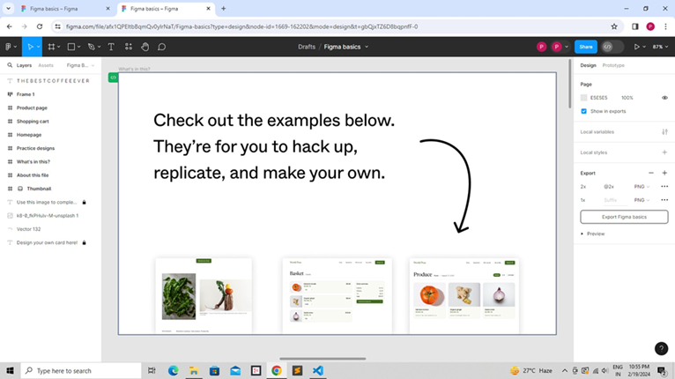

Screen:-7 Home Page

<!DOCTYPE html>

<html lang="en">

<head>

<meta charset="UTF-8">

<meta name="viewport" content="width=device-width, initial-scale=1.0">

<title>Home page</title>

<style>

.homepage-container {

width: 100%;

display: flex;

overflow: auto;

min-height: 100vh;

align-items: center;

flex-direction: column;

}

.homepage-homepage {

width: 100%;

height: 2092px;

display: flex;

overflow: hidden;

position: relative;

align-items: flex-start;

flex-shrink: 0;

background-color: rgba(255, 255, 255, 1);

}

.homepage-text {

top: 279px;

left: 217px;

color: rgba(0, 0, 0, 1);

width: 1020px;

height: auto;

position: absolute;

font-size: 64px;

font-style: Regular;

text-align: center;

font-family: Newsreader;

font-weight: 400;

line-height: 120.00000476837158%;

font-stretch: normal;

text-decoration: none;

}

.homepage-text01 {

font-weight: 400;

}

.homepage-text03 {

font-weight: 400;

}

.homepage-text05 {

font-weight: 400;

}

.homepage-button {

gap: 8px;

top: 481px;

left: 607px;

width: 227px;

height: 64px;

display: flex;

padding: 19px 32px;

overflow: hidden;

position: absolute;

align-items: flex-start;

border-radius: 8px;

background-color: rgba(66, 107, 31, 1);

}

.homepage-text08 {

top: 19px;

left: 32px;

color: rgba(255, 255, 255, 1);

height: auto;

position: absolute;

font-size: 20px;

font-style: Semi Bold;

text-align: left;

font-family: Inter;

font-weight: 700;

line-height: 129.99999523162842%;

font-stretch: normal;

text-decoration: none;

}

.homepage-text10 {

top: 1550px;

left: 309px;

color: rgba(0, 0, 0, 1);

width: 822px;

height: auto;

position: absolute;

font-size: 20px;

font-style: Regular;

text-align: left;

font-family: Inter;

font-weight: 400;

line-height: 160.0000023841858%;

font-stretch: normal;

text-decoration: none;

}

.homepage-text25 {

top: 1555px;

left: 96px;

color: rgba(0, 0, 0, 1);

width: 181px;

height: auto;

position: absolute;

font-size: 14px;

font-style: Semi Bold;

text-align: left;

font-family: Inter;

font-weight: 700;

line-height: 160.0000023841858%;

font-stretch: normal;

text-decoration: none;

}

.homepage-jonathankemper1h-hrd-io-l-fp-uunsplash1 {

top: 701px;

left: 96px;

width: 504px;

height: 693px;

position: absolute;

}

.homepage-text27 {

top: 1287px;

left: 660px;

color: rgba(0, 0, 0, 1);

width: 736px;

height: auto;

position: absolute;

font-size: 14px;

font-style: Medium;

text-align: left;

font-family: Inter;

font-weight: 500;

line-height: 160.0000023841858%;

font-stretch: normal;

text-decoration: none;

}

.homepage-text28 {

font-weight: 500;

}

.homepage-header {

top: 0px;

left: 0px;

width: 1440px;

height: 112px;

display: flex;

overflow: hidden;

position: absolute;

align-items: flex-start;

flex-shrink: 0;

}

.homepage-text30 {

top: 41px;

left: 96px;

color: rgba(66, 107, 31, 1);

height: auto;

position: absolute;

font-size: 32px;

font-style: Medium;

text-align: left;

font-family: Newsreader;

font-weight: 500;

line-height: 100%;

font-stretch: normal;

text-decoration: none;

}

.homepage-text32 {

top: 45.5px;

left: 744px;

color: rgba(0, 0, 0, 1);

height: auto;

position: absolute;

font-size: 16px;

font-style: Regular;

text-align: center;

font-family: Inter;

font-weight: 400;

line-height: 129.99999523162842%;

font-stretch: normal;

text-decoration: none;

}

.homepage-text34 {

top: 45.5px;

left: 831px;

color: rgba(0, 0, 0, 1);

height: auto;

position: absolute;

font-size: 16px;

font-style: Regular;

text-align: center;

font-family: Inter;

font-weight: 400;

line-height: 129.99999523162842%;

font-stretch: normal;

text-decoration: none;

}

.homepage-text36 {

top: 45.5px;

left: 956px;

color: rgba(0, 0, 0, 1);

height: auto;

position: absolute;

font-size: 16px;

font-style: Regular;

text-align: center;

font-family: Inter;

font-weight: 400;

line-height: 129.99999523162842%;

font-stretch: normal;

text-decoration: none;

}

.homepage-text38 {

top: 45.5px;

left: 1094px;

color: rgba(0, 0, 0, 1);

height: auto;

position: absolute;

font-size: 16px;

font-style: Regular;

text-align: center;

font-family: Inter;

font-weight: 400;

line-height: 129.99999523162842%;

font-stretch: normal;

text-decoration: none;

}

.homepage-cartbutton {

gap: 8px;

top: 32px;

left: 1218px;

width: 126px;

height: 48px;

display: flex;

padding: 14px 23px;

overflow: hidden;

position: absolute;

align-items: center;

flex-shrink: 0;

border-radius: 8px;

justify-content: center;

background-color: rgba(66, 107, 31, 1);

}

.homepage-text40 {

top: 13.5px;

left: 23px;

color: rgba(255, 255, 255, 1);

height: auto;

position: absolute;

font-size: 16px;

font-style: Semi Bold;

text-align: center;

font-family: Inter;

font-weight: 700;

}

.homepage-stocksytxp226f62b2a-ne300-medium45821931 {

top: 791px;

left: 660px;

width: 780px;

height: 480px;

position: absolute;

}

</style>

</head>

<body>

<div>

<div class="homepage-container">

<div class="homepage-homepage">

<span class="homepage-text">

<span class="homepage-text01">We’re</span>

<span>farmers</span>

<span class="homepage-text03">,</span>

<span>purveyors</span>

<span class="homepage-text05">, and</span>

<span>eaters</span>

<span>of organically grown food.</span>

</span>

<button class="homepage-button">

<span class="homepage-text08"><span>Browse our shop</span></span>

</button>

<span class="homepage-text10">

<span>

<span>We believe in produce. Tasty produce. Produce like:</span>

<br />

<span></span>

<br />

<span>

Apples. Oranges. Limes. Lemons. Guavas. Carrots. Cucumbers. Jicamas.

Cauliflowers. Brussels sprouts. Shallots. Japanese eggplants.

Asparagus. Artichokes—Jerusalem artichokes, too. Radishes. Broccoli.

Baby broccoli. Broccolini. Bok choy. Scallions. Ginger. Cherries.

Raspberries. Cilantro. Parsley. Dill.

</span>

<br />

<span></span>

<br />

<span>What are we forgetting?</span>

<br />

<span></span>

<br />

<span>

Oh! Onions. Yams. Avocados. Lettuce. Arugula (to some, “rocket”).

Persian cucumbers, in addition to aforementioned “normal” cucumbers.

Artichokes. Zucchinis. Pumpkins. Squash (what some cultures call

pumpkins). Sweet potatoes and potato-potatoes. Jackfruit. Monk

fruit. Fruit of the Loom. Fruits of our labor (this website).

Sorrel. Pineapple. Mango. Gooseberries. Blackberries. Tomatoes.

Heirloom tomatoes. Beets. Chives. Corn. Endive. Escarole, which, we

swear, we’re vendors of organic produce, but if you asked us to

describe what escaroles are...

</span>

</span>

</span>

<span class="homepage-text25"><span>WHAT WE BELIEVE</span></span>

<img src="https://aheioqhobo.cloudimg.io/v7/_playground-bucket-v2.teleporthq.io_/a4004044-c009-433c-83bb-f7e5eae54458/f49ee370-f603-4e8a-8abc-da66b9471ded?org_if_sml=1730272&amp;force_format=original"

alt="jonathankemper1HHrdIoLFpUunsplash14368"

class="homepage-jonathankemper1h-hrd-io-l-fp-uunsplash1" />

<span class="homepage-text27">

<span class="homepage-text28">Central California</span>

<span> — The person who grew these was located in Central California and, er, hopefully very well-compensated.

</span>

</span>

<div class="homepage-header">

<span class="homepage-text30"><span>World Peas</span></span>

<span class="homepage-text32"><span>Shop</span></span>

<span class="homepage-text34"><span>Newstand</span></span>

<span class="homepage-text36"><span>Who we are</span></span>

<span class="homepage-text38"><span>My profile</span></span>

<button class="homepage-cartbutton">

<span class="homepage-text40"><span>Basket (3)</span></span>

</button>

</div>

<img src="https://aheioqhobo.cloudimg.io/v7/_playground-bucket-v2.teleporthq.io_/a4004044-c009-433c-83bb-f7e5eae54458/3dd10b95-c3ca-4f02-9555-1d26dca09bb3?org_if_sml=1357065&amp;force_format=original"

alt="Stocksytxp226f62b2aNe300Medium458219314508"

class="homepage-stocksytxp226f62b2a-ne300-medium45821931" />

</div>

</div>

</div>

</body>

</html>

Output:-

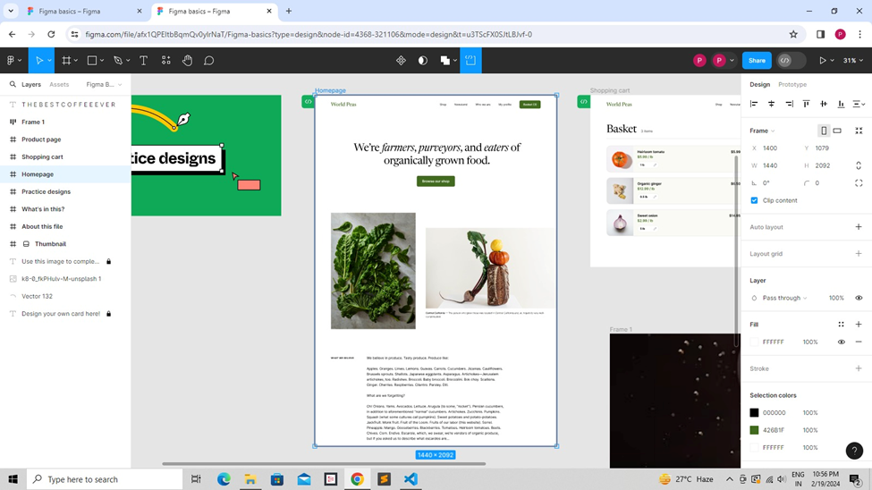

Screen:-8 Drink Page

<!DOCTYPE html>

<html lang="en">

<head>

<meta charset="UTF-8">

<meta name="viewport" content="width=device-width, initial-scale=1.0">

<title>Drink Page</title>

<style>

.drink-page-container {

width: 100%;

display: flex;

overflow: auto;

min-height: 100vh;

align-items: center;

flex-direction: column;

}

.drink-page-drink-page {

width: 100%;

height: 1825px;

display: flex;

overflow: hidden;

position: relative;

align-items: flex-start;

flex-shrink: 0;

background-color: rgba(109, 109, 109, 1);

}

.drink-page-image20 {

top: 0px;

left: 0px;

width: 1464px;

height: 1355px;

position: absolute;

}

.drink-page-image21 {

top: 0px;

left: 1464px;

width: 1376px;

height: 1355px;

position: absolute;

}

.drink-page-rectangle11 {

top: 1465px;

left: 464px;

width: 576px;

height: 200px;

position: absolute;

}

.drink-page-rectangle12 {

top: 1465px;

left: 1896px;

width: 576px;

height: 200px;

position: absolute;

}

.drink-page-text {

top: 1482px;

left: 542px;

color: rgba(0, 0, 0, 1);

height: auto;

position: absolute;

font-size: 128px;

font-style: Semi Bold;

text-align: center;

font-family: Inter;

font-weight: 700;

line-height: 129.99999523162842%;

font-stretch: normal;

text-decoration: none;

}

.drink-page-text2 {

top: 1482px;

left: 2072px;

color: rgba(0, 0, 0, 1);

height: auto;

position: absolute;

font-size: 128px;

font-style: Semi Bold;

text-align: center;

font-family: Inter;

font-weight: 700;

line-height: 129.99999523162842%;

font-stretch: normal;

text-decoration: none;

}

</style>

</head>

<body>

<div>

<link href="./drink-page.css" rel="stylesheet" />

<div class="drink-page-container">

<div class="drink-page-drink-page">

<img

src="https://aheioqhobo.cloudimg.io/v7/_playground-bucket-v2.teleporthq.io_/a4004044-c009-433c-83bb-f7e5eae54458/c8e35da3-0454-4d22-bf29-c59ee6c37c9e?org_if_sml=1242330&amp;force_format=original"

alt="image206824"

class="drink-page-image20"

/>

<img

src="https://aheioqhobo.cloudimg.io/v7/_playground-bucket-v2.teleporthq.io_/a4004044-c009-433c-83bb-f7e5eae54458/32fcc3bf-13de-4057-a9a5-89940d57fbfd?org_if_sml=1179115&amp;force_format=original"

alt="image216824"

class="drink-page-image21"

/>

<img

src="https://aheioqhobo.cloudimg.io/v7/_playground-bucket-v2.teleporthq.io_/a4004044-c009-433c-83bb-f7e5eae54458/003a271e-4393-4e76-9abb-3b11ac9174a4?org_if_sml=1983&amp;force_format=original"

alt="Rectangle116824"

class="drink-page-rectangle11" />

<img

src="https://aheioqhobo.cloudimg.io/v7/_playground-bucket-v2.teleporthq.io_/a4004044-c009-433c-83bb-f7e5eae54458/211df05d-cf81-4764-8d37-9bc90b368ea6?org_if_sml=1983&amp;force_format=original"

alt="Rectangle126824"

class="drink-page-rectangle12" />

<span class="drink-page-text"><span>Coffee</span></span>

<span class="drink-page-text2"><span>Tea</span></span>

</div>

</div>

</div>

</body>

</html>

Output:-

